Brain Stroke Dataset: Decision Tree Prediction Report

Overview
This document reports summaries and interpretations on factors identified as statistically significant to brain stroke using results from three different decision tree models. The models include original, balanced, and tuned decision trees, where the two latter ones are modified from the original tree model to enhance performance metrics. The final model, tuned decision tree model, was selected for best interpretability and prediction performance. The first three sections each show model summary tables, variable importance, accuracy tests, ROC Curve, and decision tree plot obtained using two programming languages, R and Python. The document ends with an interpretation of major statistics and overall conclusion on the significant predictors of stroke.

Data
Dataset | Observations | Stroke Cases | Stroke Rate (%)
Original | 4891 | 248 | 4.98%
Train | 2,491 | 123 | 4.94%
Test | 2,490 | 125 | 5.02%

- The original patient dataset was split into 50% training set and 50% testing set using random data partitioning functions in R and Python libraries.
- The splitting algorithm ensured stroke rate was approximately similar between training and testing set.
- Only the training set was used for constructing tree models.
- The testing set was used to obtain predicted stroke probabilities and measure overall model performance.

#1 Original Model
Software used: R Studio, Spyder (Python)
Training time | 0.0566 seconds

Summary Table
Component | Value
Formula | stroke ~ Gender + age + hypertension + heart_disease + ever_married + work_type + Residence_type + avg_glucose_level + bmi + smoking_status
Method | class
Training Observations (n) | 2491
CP (Complexity Parameter) | 0.008130081
Number of Splits (nsplit) | 0
Relative Error (rel error) | 1.0
Cross-Validation Error (xerror) | 0
Cross-Validation Std Dev (xstd) | 0
Predicted Class | 0
Expected Loss | 0.04937776
Class Counts | 2368 non-stroke, 123 stroke
Class Probabilities | 0.951 non-stroke, 0.049 stroke
Variable Importance | NULL

Key Observations
- The tree did not branch/split at all
  - This indicates that the dataset is highly imbalanced
    - 2368 non-stroke cases ~95%
    - 123 stroke cases ~5% stroke prevalence
    - Tree likely minimizes error by predicting No Stroke all the time
    - This corresponds with the probabilities listed (0.951 non-stroke, 0.049 stroke)
  - No split that reduces impurity
- Model predicts the majority class (“No Stroke”) for every patient
- Since no splits occurred, no variables used variable importance is NULL
- The class imbalance is severe enough that a standard decision tree cannot detect stroke patterns effectively.

Accuracy Test (Python & R)
Threshold: 0.5
- Test Accuracy: 0.947
- Sensitivity: 0.0161
- Specificity: 0.9958
- Confusion Matrix:
Actual
Predicted | 0 | 1
0 | 2357 | 10
1 | 122 | 2

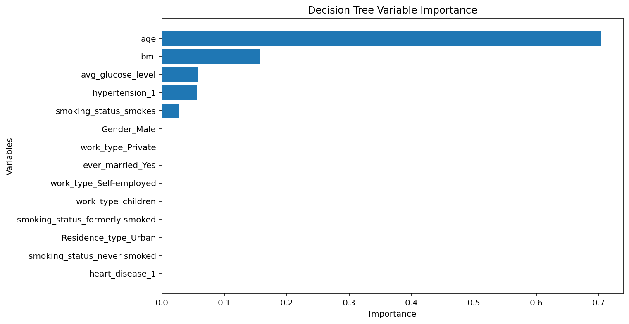
Variable Importance Graph (Python)
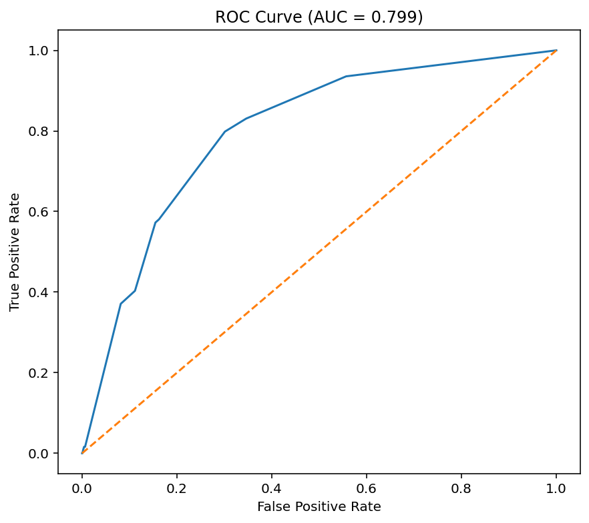
ROC Curve (Python)

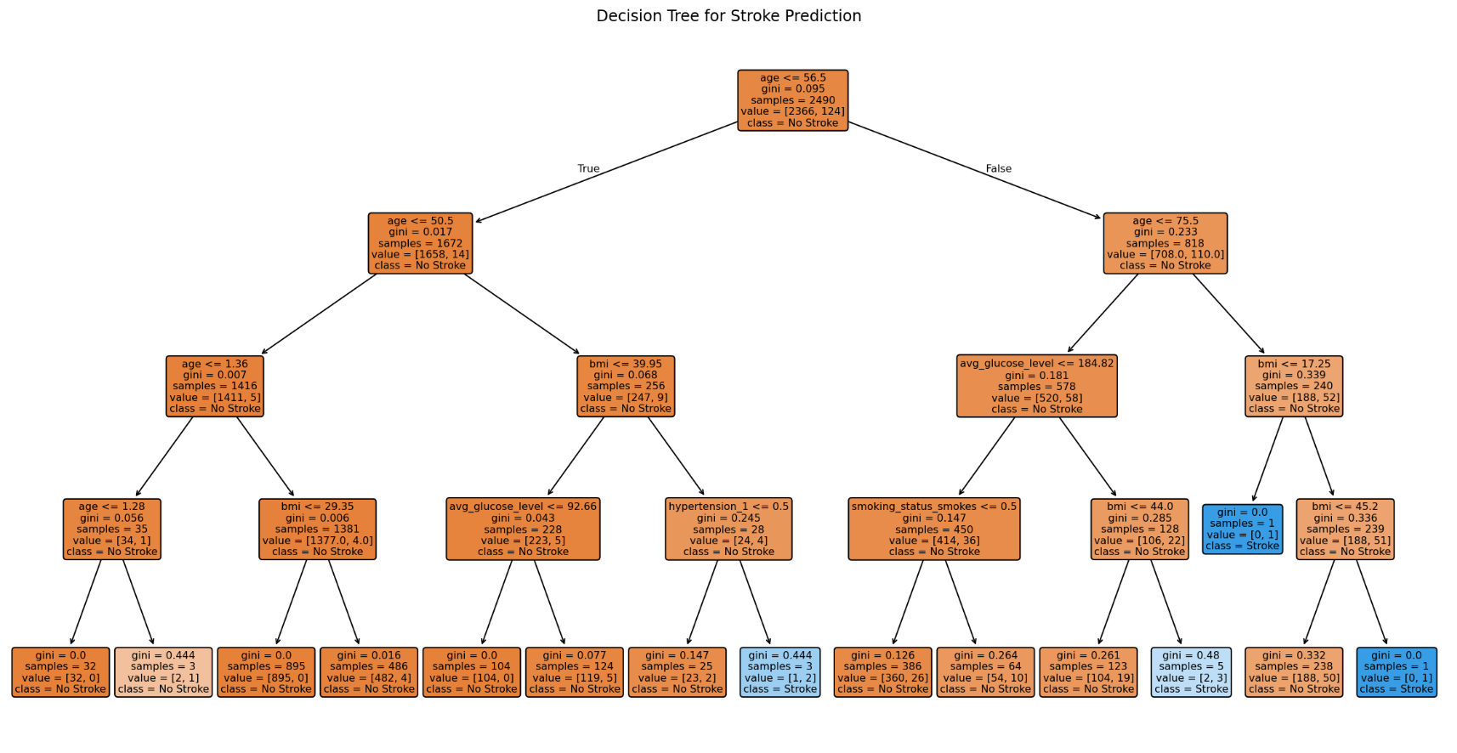
Decision Tree Plot

#2 Balanced Tree Model
Software used: R Studio
Feature: Class Balancing
- Created balanced training data (50% stroke, 50% non-stroke cases)
- Use it to build a new tree model

Summary Table
Component | Result
Model Type | Classification Tree (method = "class")
Training Observations | 246
Class Distribution | 123 non-stroke, 123 stroke
Tree Splits | 3 splits
Main Splitting Variable | Age
Most Important Variables | Age, ever_married, work_type, bmi, hypertension
Root Node Accuracy | 50% / 50%
First Split | Age < 48.5
Best Stroke Prediction Region | Older individuals (≥48.5)
Highest Stroke Probability Node | Node 13
Lowest Stroke Probability Node | Node 2

Variable Importance Table
Variable | Importance Score
Age | 49.96
ever_married | 8.51
work_type | 7.94
bmi | 6.47
hypertension | 3.22

Complexity Parameter (CP) Table
CP | Number of Splits | Relative Error | Cross-Validation Error (xerror) | xstd
0.56910569 | 0 | 1.0000000 | 1.1788618 | 0.06272953
0.03252033 | 1 | 0.4308943 | 0.4634146 | 0.05380166
0.01000000 | 3 | 0.3658537 | 0.4471545 | 0.05312823

Key Observations
- Age is the strongest predictor
  - Importance score: ~50
  - Root node (greatest reduction in classification impurity
  - Patients younger than ~48 years were mostly classified as non-stroke.
  - This supports our earlier logistic regression findings where age had the strongest statistical significance.
- Hypertension emerges as important predictor
  - Appears in later branches (Node 3, Node 6)
  - Node 3 contained older patients, higher hypertension prevalence, higher BMI/glucose
  - This suggests hypertension interacts with age in determining stroke risk, which aligns with the interaction logistic regression model.
- BMI contributed moderately in refining the predictions (adds strength to age:bmi interaction term)
- Work type and Marriage status were identified as meaningful classification variables
- Overall, there is a consistency observed across models in identifying significant factors

Accuracy Test
Best Threshold: 0.531295
- Test Accuracy: 0.6671
- Sensitivity: 0.8560
- Specificity: 0.6571
- Confusion Matrix:
Actual
Predicted | 0 | 1
0 | 1554 | 18
1 | 811 | 107

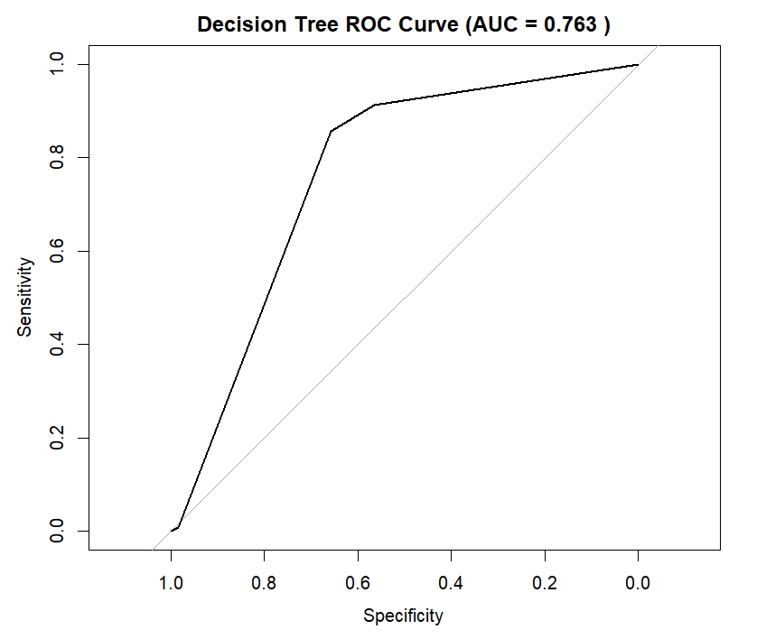
ROC Curve

#3 Tuned Tree Model (Lower minsplit)
Software used: R Studio, Spyder (Python)

Model Summary - R
Training Time | 0.0372 seconds

Model Configuration
Setting | Value
Method | Classification Tree (rpart)
Dataset Size | 2491 observations
minsplit | 10
cp | 0.0001
maxdepth | 5

Complexity Parameter (CP) Table
CP | Number of Splits | Relative Error | Cross-Validation Error (xerror) | xstd
0.010163 | 0 | 1.0000 | 1.0000 | 0.0879
0.008130 | 4 | 0.9593 | 1.0488 | 0.0899
0.004065 | 6 | 0.9431 | 1.1382 | 0.0935
0.000100 | 10 | 0.9268 | 1.2358 | 0.0971

Model Summary - Python
Training Time | 0.0148 seconds

Model Configuration
Metric | Value
Tree Depth | 5
Number of Nodes | 39
Number of Leaves | 20
Max Depth Parameter | 5
Min Samples Split | 10
Min Samples Leaf | 5
CCP Alpha | 0.0001

Best-Pruned Tree (based on minimum cross-validation error)
Metric | Value
CCP Alpha | 0.002153
Leaves | 2
Tree Depth | 1
Train Error | 0.0494
CV Error | 0.0494
CV Std | 0.0018

Variable Importance
Variable Importance (R):
Rank | Variable | Importance Score
1 | age | 50
2 | avg_glucose_level | 16
3 | bmi | 15
4 | ever_married | 7
5 | work_type | 6
6 | hypertension | 5
7 | smoking_status | 1
8 | Residence_type | 1

Variable Importance (Python):
Rank | Variable | Importance | Importance (%)
1 | age | 0.452082 | 45.21%
2 | avg_glucose_level | 0.176995 | 17.70%
3 | bmi | 0.176192 | 17.62%
4 | hypertension_1 | 0.058778 | 5.88%
5 | work_type_Private | 0.039236 | 3.92%
6 | heart_disease_1 | 0.037456 | 3.75%
7 | ever_married_Yes | 0.030903 | 3.09%
8 | smoking_status_never smoked | 0.028358 | 2.84%
9 | Gender_Male | 0.000000 | 0.00%
10 | work_type_Self-employed | 0.000000 | 0.00%
11 | smoking_status_formerly smoked | 0.000000 | 0.00%
12 | Residence_type_Urban | 0.000000 | 0.00%
13 | work_type_children | 0.000000 | 0.00%
14 | smoking_status_smokes | 0.000000 | 0.00%

Variable Importance Plot
Variable Importance Plot (R)
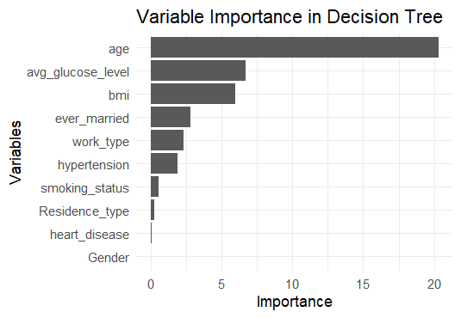
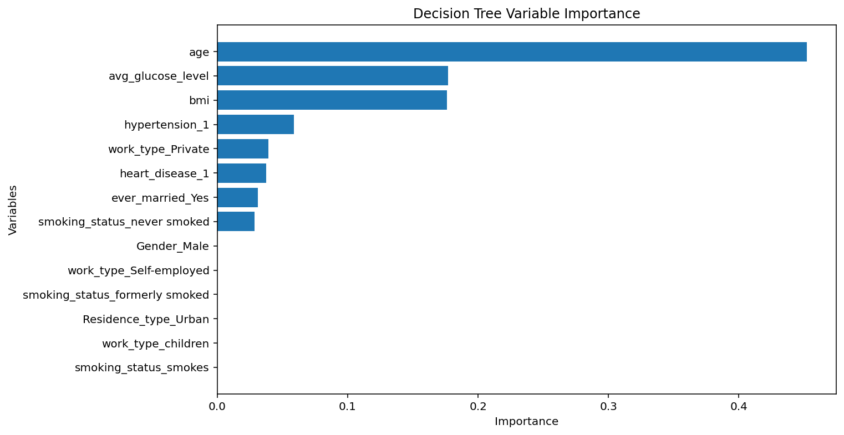
Variable Importance Plot (Python)

Accuracy Test
Accuracy Test (R):
Best Threshold: 0.04865
- Test Accuracy: 0.6056
- Sensitivity: 0.8960
- Specificity: 0.5903
- The model correctly identifies most stroke cases (~89.6%)
- Many false positives (lower specificity)
- Confusion Matrix:
Actual
Predicted | 0 | 1
0 | 1396 | 13
1 | 969 | 112

Accuracy Test (Python):
Best Threshold: 0.0512
- Test Accuracy: 0.6916
- Sensitivity: 0.8240
- Specificity: 0.6846
- The model correctly identifies most stroke cases (~82.4%)
- Confusion Matrix:
Actual
Predicted | 0 | 1
0 | 1619 | 22
1 | 746 | 103

ROC Curve
ROC Curve (R):
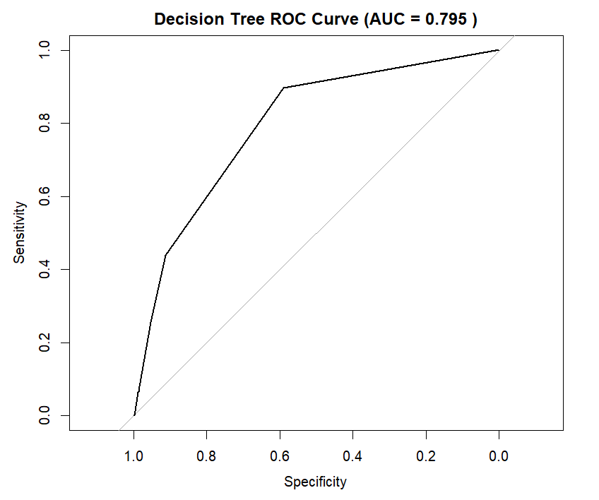
ROC Curve (Python):
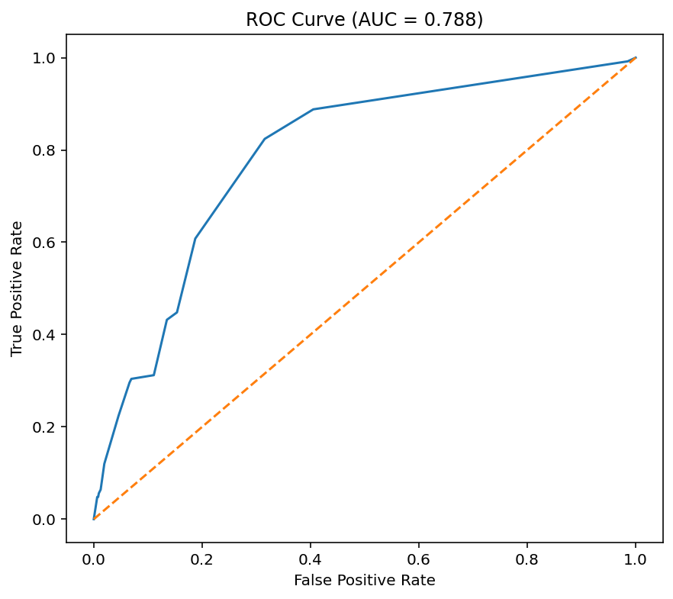
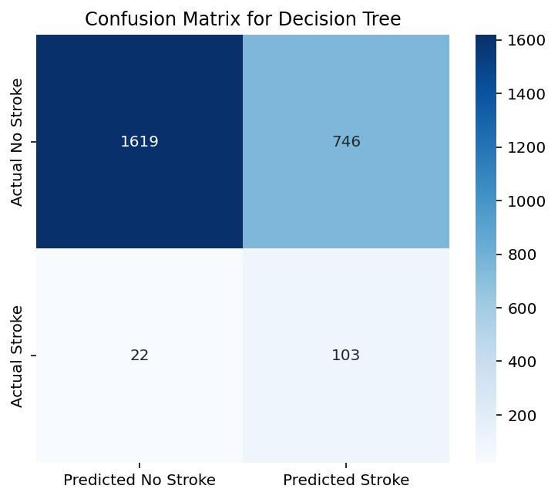
Confusion Matrix Heatmap (Python):

Although R and Python implementations produced slightly different optimal thresholds and performance metrics, the overall predictive behavior of the models was consistent. Differences are expected because the two platforms handle categorical splitting, pruning, and probability estimation differently.

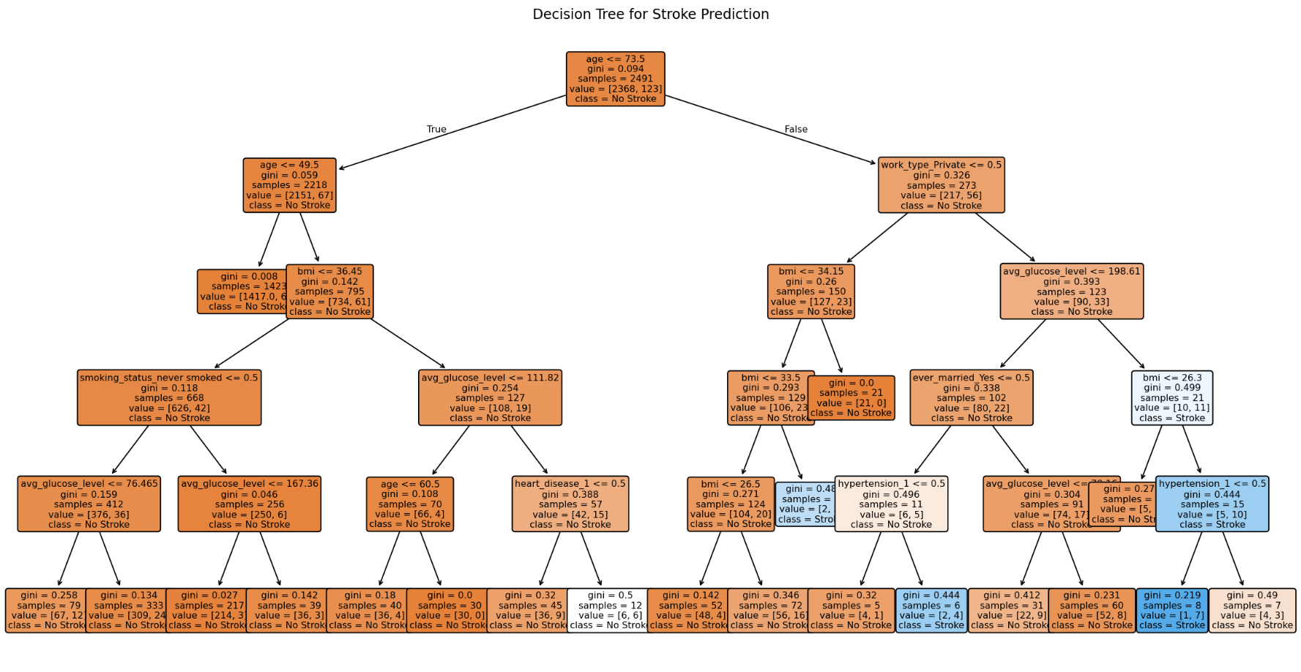
Decision Tree Plot (Python):

Key Observations
- Age is the strongest predictor (top split, highest importance variable)
- Hypertension, Glucose level, and BMI are major contributors (branches, node splits)
- Cross-validation error increased as tree became more complex possible overfitting
- Smoking and residence type had weak influence (low importance scores)
- Overall, the results support our earlier logistic regression findings where age had the strongest statistical significance.

